Twister 2.0

Design Document

## Content

Inspiratie 3

Icons 6

Kleurenpalet 7

Lettertype 7

## Inspiratie

<https://kahoot.com/>

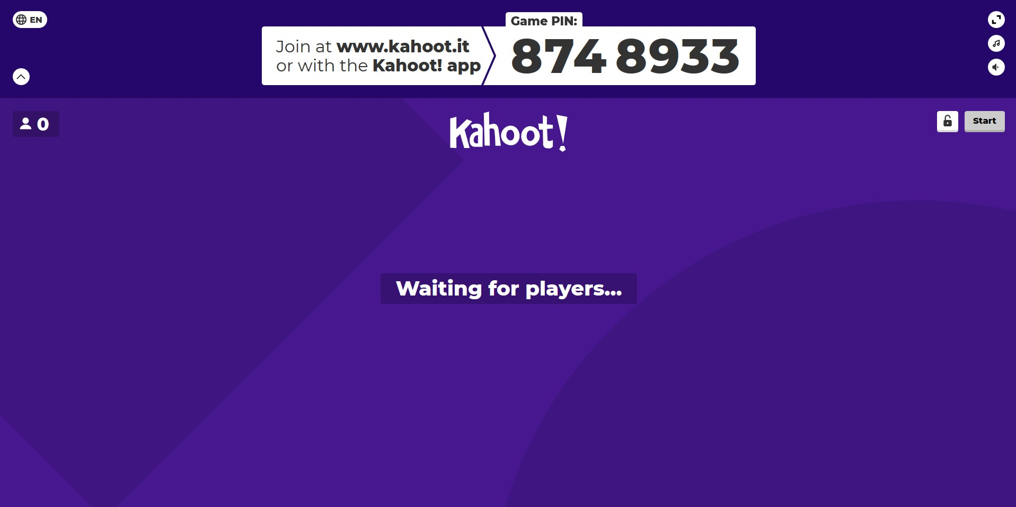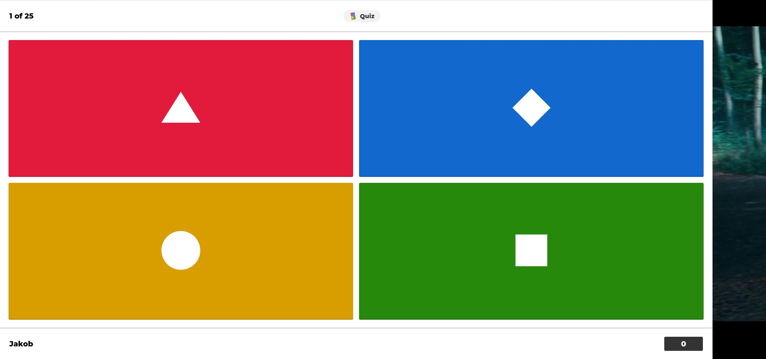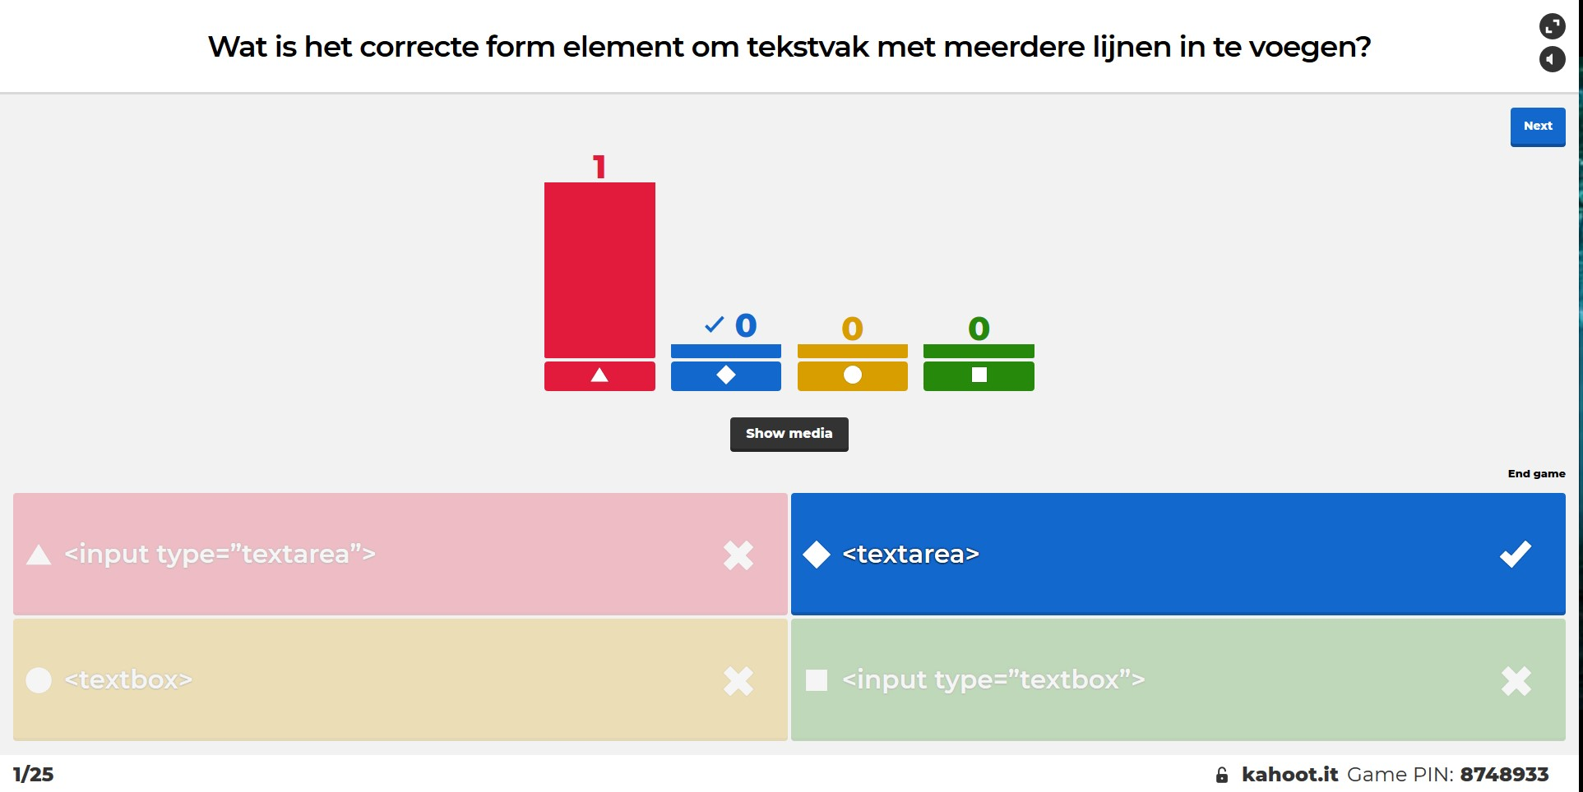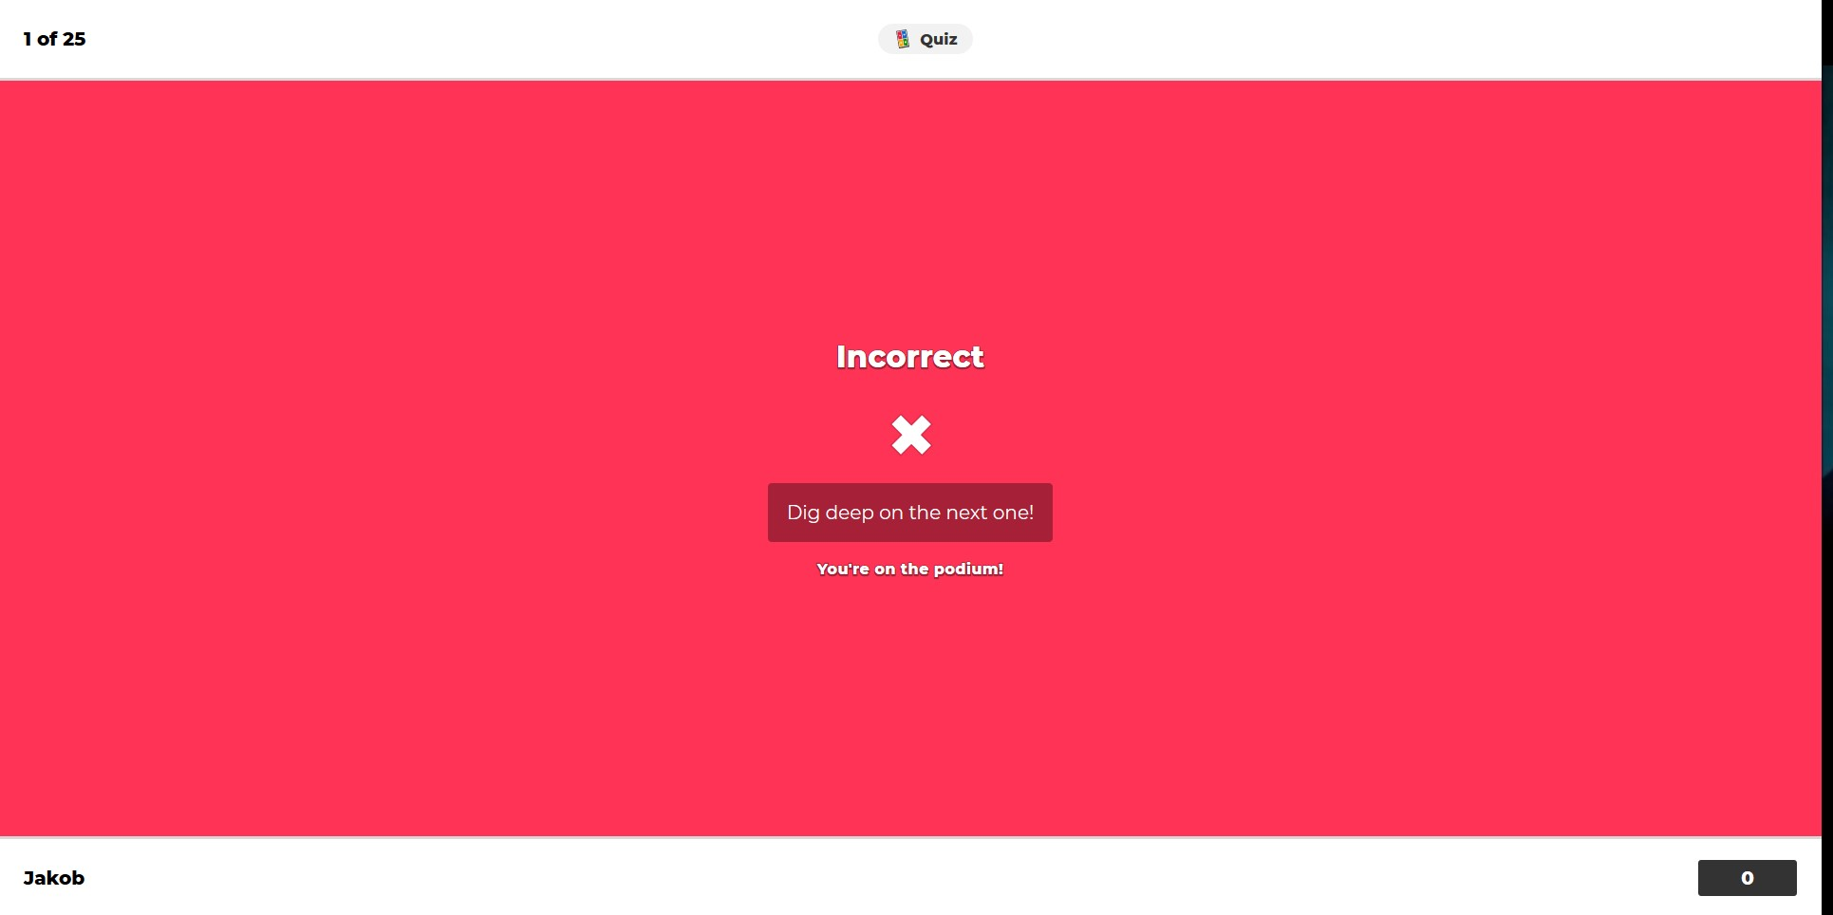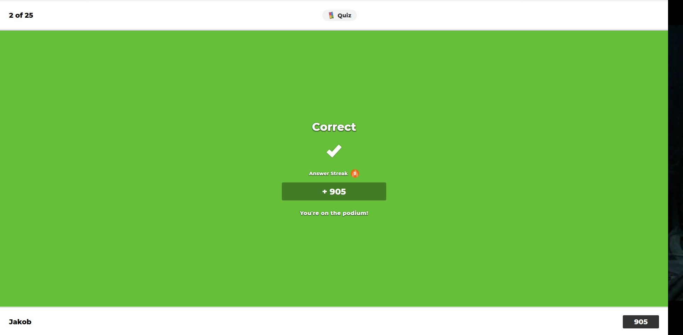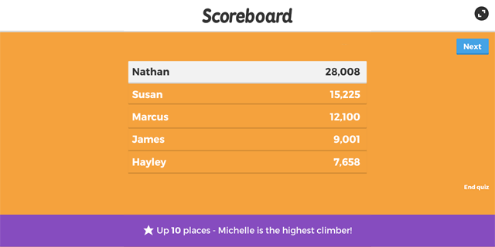

<https://dribbble.com/shots/9181725-Mobile-App-UI-Game-for-Kids>

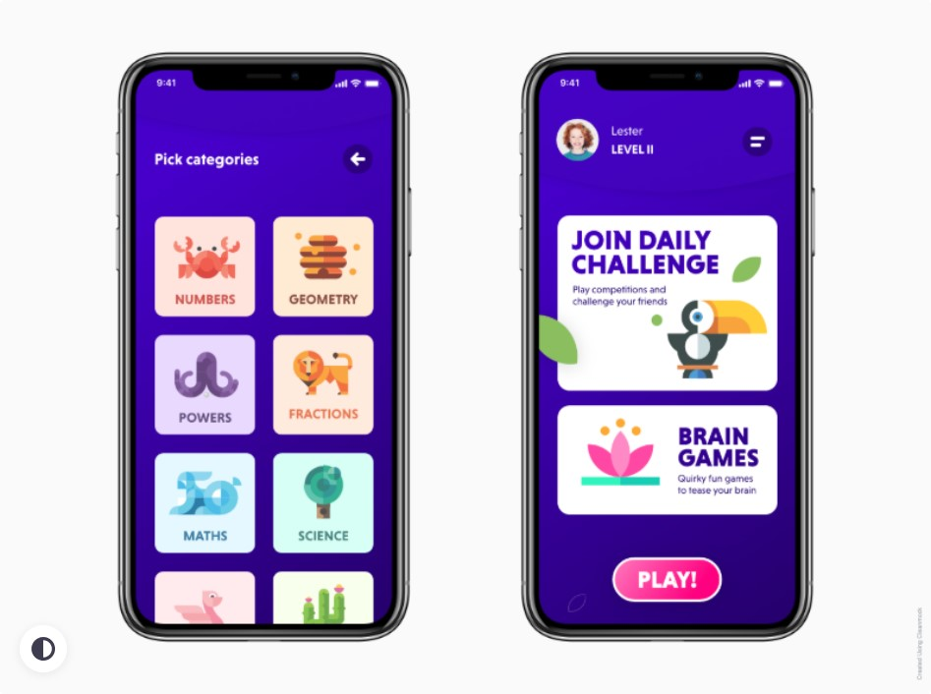

<https://dribbble.com/shots/10961139-Vegetables-Game-App>

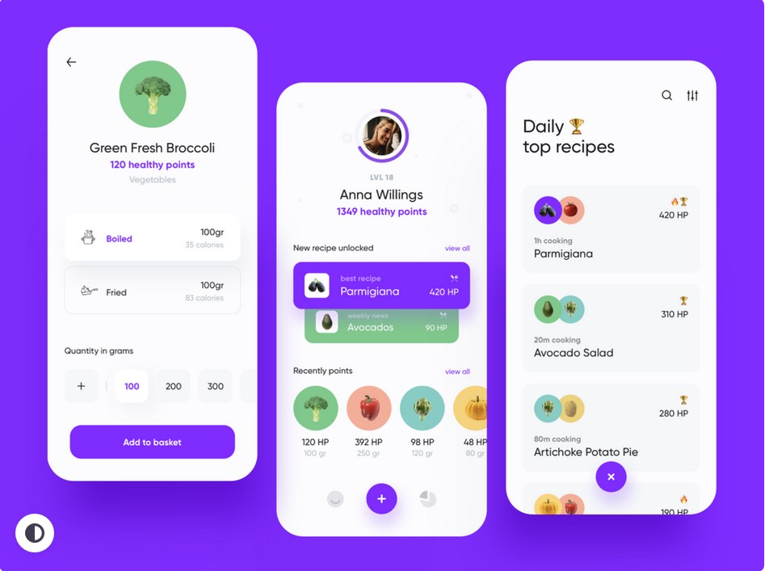

<https://dribbble.com/shots/14223544-Ceki-App-Redesign>

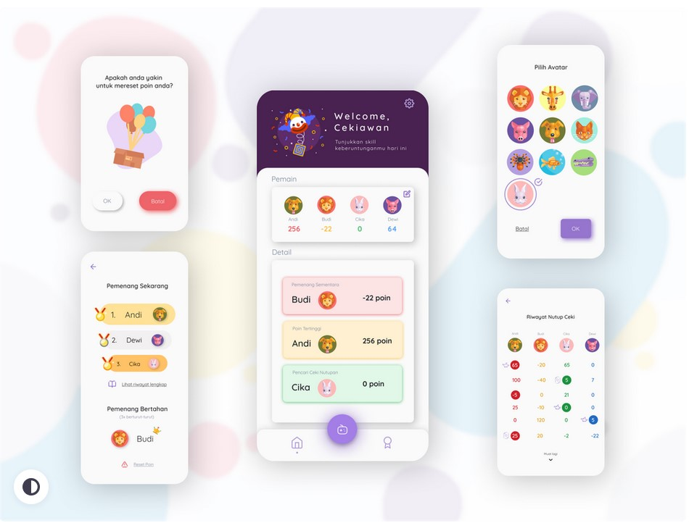

## Icons

|  |  |  |
| --- | --- | --- |
|  |  |  |
|  |  |  |

## Kleurenpalet

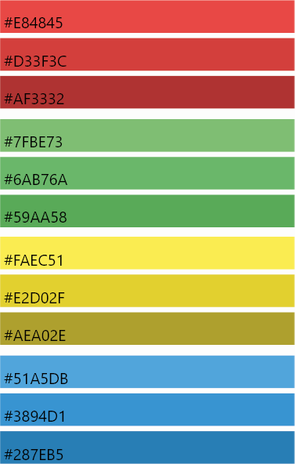

## Lettertype

Arial Rounded MT Bold

